***Week 15 Assignment***

***Database Design & Programming with MySQL***

***Social media users data analysis***

BY: JOY STACY MUTHOKA

***CALCULATING THE AVERAGE TIME SPENT BY PLATFORM***

SELECT

platform,

COUNT(*) AS user_count,

AVG(time_spent) AS avg_time_spent

FROM

social_media_data

GROUP BY

platform

ORDER BY

avg_time_spent DESC;

***Results***

| platform | user_count | avg_time_spent |
| --- | --- | --- |
| Instagram | 363 | 5.1515 |
| Facebook | 307 | 5.0554 |
| YouTube | 330 | 4.8697 |

From the above data query: you are able to :

a. Determine which platform has most users.

b. Compare engagement levels across different social media platforms.

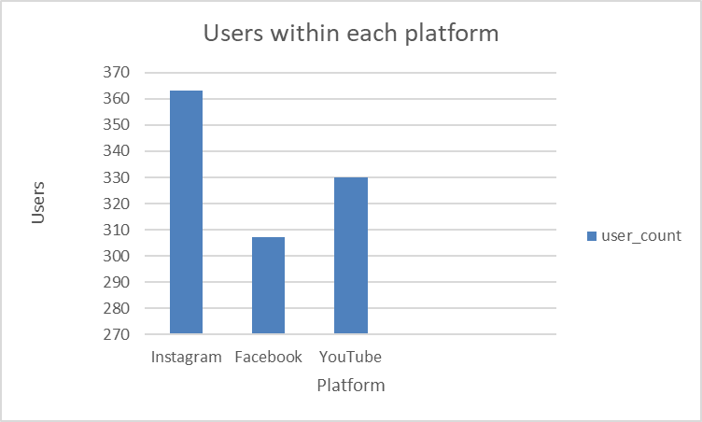

*Above is a chart that shows users within each platform.*

***CALCULATING INCOME DISTRIBUTION BY AGE GROUP***

SELECT

CASE

WHEN age BETWEEN 18 AND 24 THEN '18-24'

WHEN age BETWEEN 25 AND 34 THEN '25-34'

WHEN age BETWEEN 35 AND 44 THEN '35-44'

ELSE '45+'

END AS age_group,

COUNT(*) AS user_count,

AVG(income) AS avg_income,

MAX(income) AS max_income,

MIN(income) AS min_income

FROM

social_media_data

GROUP BY

age_group

ORDER BY

age_group;

***Results***

| age_group | user_count | avg_income | max_income | min_income |
| --- | --- | --- | --- | --- |
| 18-24 | 154 | 15214.6104 | 19965 | 10048 |
| 25-34 | 199 | 15103.4523 | 19952 | 10012 |
| 35-44 | 217 | 15498.1290 | 19969 | 10021 |
| 45+ | 430 | 14658.3535 | 19980 | 10075 |

From the data, you are able to :

1. Understand income distribution among different age demographics.
2. Identify income trends and disparities across age groups.

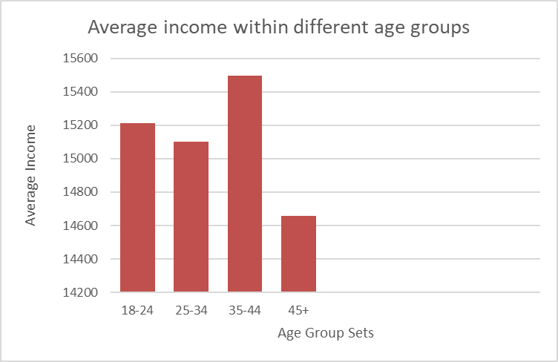

*Above is a chart that shows the average income comparison of the different age groups.*

***CALCULATING TIME SPENT IN INSTAGRAM VS YOUTUBE ON TRAVEL***

SELECT

platform,

interests,

AVG(time_spent) AS avg_time_spent

FROM

social_media_data

WHERE

interests = 'travel'

AND platform IN ('Instagram', 'YouTube')

GROUP BY

platform,

interests;

***Results***

| platform | interests | avg_time_spent |
| --- | --- | --- |
| Instagram | Travel | 5.3796 |
| YouTube | Travel | 4.9516 |

From the data, you are able to :

1. Know which platform is preferred for Travel content
2. Helps identify engagement patterns such as users prefer short reels on instagram for Travel compared to long video content on youtube.

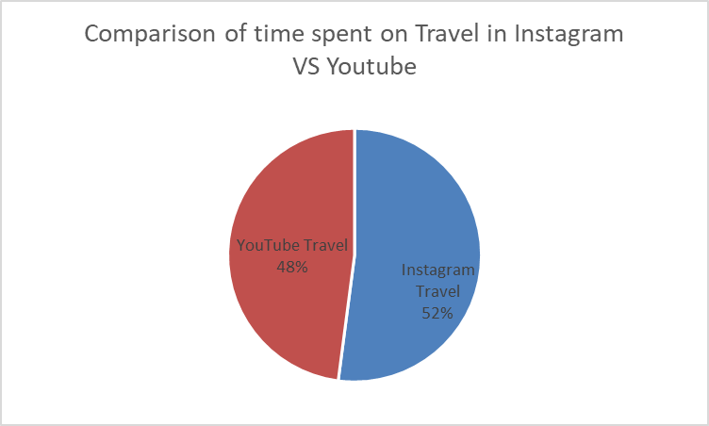

*Above is a chart that shows comparison of average time spent between Instagram platform and Youtube platform based on Travel interest.*

QUESTIONS

1. What is preferred interest among female gender across all platforms
2. Which platform do male gender spend most of their time

***Preferred interest among female gender query***

SELECT

interests,

COUNT(*) AS interest_count

FROM

social_media_data

WHERE

gender = 'Female'

GROUP BY

interests

ORDER BY

interest_count DESC;

***Results***

| interests | interest_count |
| --- | --- |
| Lifestyle | 122 |
| Sports | 109 |
| Travel | 100 |

From this you identify Lifestyle as preferred interest among women.

***Platform males spend most time on***

SELECT

platform,

SUM(time_spent) AS total_time_spent

FROM

social_media_data

WHERE

gender = 'Male'

GROUP BY

platform

ORDER BY

total_time_spent DESC;

***Results***

| platform | total_time_spent |
| --- | --- |
| Instagram | 623 |
| Facebook | 564 |
| YouTube | 438 |

From the data, the male gender spend more time on Instagram.